# SI206 W24 Project 2

## Introduction:

In this project, you will work with [BeautifulSoup](https://www.crummy.com/software/BeautifulSoup/bs4/doc/) and html files with data from [Airbnb.com](https://www.airbnb.com/). Airbnb’s public facing website has lots of data from their database of vacation rentals, however, this database is not publically accessible. We can use web scraping to gather data for our own analysis. *Web scraping* is the process of taking messy data from the web, processing it, cleaning it, and turning it into something useful for analysis.

### Web Scraping & Accountability:

*Accountability* is important for any democracy. Watchdogs and investigative journalists use web scraping from pages publicly available on the internet to hold corporations and governments socially accountable for their products and decisions.

For example, [The Center for Investigative Reporting](https://revealnews.org/article/these-police-officers-were-members-of-extremist-groups-on-facebook/) used web scraping to gather members of extremist Facebook hate groups and police Facebook groups. They then cross-referenced the two lists and confirmed hundreds of users that were both currently employed in law enforcement and a member of an online hate group. More than 50 police departments took action or launched internal investigations after the journalists called them with their findings.

### Context for this project:

Starting in the 1990s, the San Francisco Bay Area has had an affordable housing shortage. The introduction of Airbnb.com caused serious concerns about the platform further exacerbating this crisis by taking potential rental units off the housing market. As of 2015, lawmakers have attempted to regulate this by requiring potential listers to receive a business license from the local government before offering short-term rentals (rentals of less than 30 days). This allows the government to manage the number of short-term rental units in the city. Additionally, San Francisco Law requires platforms that provide the service of connecting listers and renters (such as airbnb, vrbo, etc) to reasonably verify that listers are registered with the government. However, this system is held accountable through complaints to the local government. **The government will investigate and hold listers and Airbnb accountable only after receiving a complaint.**

## In this project:

This project consists of 7 questions and an extra point question. We will be investigating if Airbnb is complying with these local laws in order to strengthen this system of accountability. Airbnb does not make their database of vacation rentals publicly available. We must use web-scraping to gather this information. Web scraping was used by the group “Inside Airbnb” to add data to the debate of Airbnb’s impact on residential communities. You can explore their historical data [here](http://insideairbnb.com/san-francisco)!

Note that Airbnb.com explicitly forbids the use of web-scraping in their terms of service:

*“Do not use bots, crawlers, scrapers, or other automated means to access or collect data or other content from or otherwise interact with the Airbnb Platform.”*

However, the enforceability of this term is still not fully understood. There have been [several high profile US Supreme Court cases](https://www.eff.org/deeplinks/2022/04/scraping-public-websites-still-isnt-crime-court-appeals-declares) debating the legality of web scraping. In order to not cause you to violate airbnb’s terms of service, we’ve provided several static pages in the html_files folder for you to use that were obtained from Airbnb.com legally.

Specifically, we went to Airbnb.com on February 13th, 2023, searched for short term rentals in San Francisco’s Mission District (the district with the highest density of Airbnbs), downloaded the first page of results given by the website’s algorithm, as well as the page of each listing on the first page. Because we loaded the website and downloaded the pages by hand, this is not against the site’s terms of service.

**You will be scraping this data taken from Airbnb.com, cleaning it, and extracting information from it.** You will need to use the [BeautifulSoup](https://www.crummy.com/software/BeautifulSoup/bs4/doc/) library to parse through the HTML documents. We have provided static html documents for you to use. While you can open HTML files in VSCode, it will often be easier to find what you’re looking for by opening the files **in your web browse**r and using the inspector tools (**see the screenshot below**). In Chrome and Firefox you can access the inspector tools by right clicking. In Safari, you will need to make sure you enable features for web developers ([see here for more information](https://developer.apple.com/documentation/safari-developer-tools/develop-menu)).

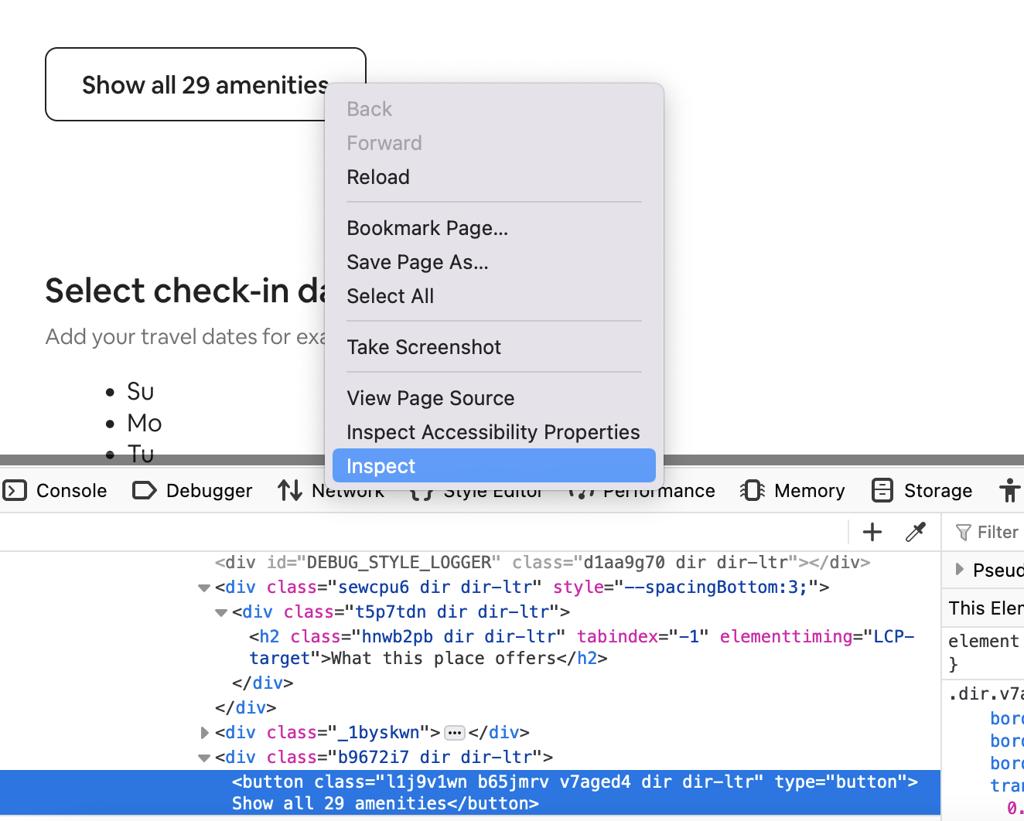

Based on the example above, we can use our inspector tools to find out that if we’re looking for the number of amenities, we might search for <div> tags with the class “b9672i7 dir dir-ltr” or <button> tags with the class “l1j9v1wn b65jmrv v7aged4 dir dir-ltr”

**NOTE**: The static html documents may appear to be missing several elements or rearranged in an awkward or unexpected way. This is because the static documents do not contain extra [CSS](https://en.wikipedia.org/wiki/CSS) or [JavaScript](https://www.javascript.com/) files that are necessary to make the site look how the designers wanted. If you’d like to see the page with html, css, and javascript elements, use this following link to see the search results page: [Airbnb Search: Mission District, San Francisco, California](https://www.airbnb.com/s/Mission-District--San-Francisco--California--United-States/homes?tab_id=home_tab&refinement_paths%5B%5D=%2Fhomes&flexible_trip_lengths%5B%5D=one_week&price_filter_input_type=0&query=Mission%20District%2C%20San%20Francisco%2C%20CA&place_id=ChIJIzOAXzx-j4ARiVHkPQcAWAM&date_picker_type=calendar&source=structured_search_input_header&search_type=autocomplete_click&federated_search_session_id=73145d57-bee5-41b1-adee-3576e3f695e6&pagination_search=true) and this link to see an example Airbnb listing page: [Airbnb Listing ID: 1944564](https://www.airbnb.com/rooms/1944564). You can then use the “[Inspect element](https://en.wikipedia.org/wiki/Web_development_tools)” feature of your browser to look at the html.

**After you’ve implemented all of the required functions, you will need to write test cases for each one.** We have provided some test cases and guidance for what to test for in the comments, but it will be up to you to implement the logic in the code.

**IMPORTANT NOTE ABOUT OPENING FILES:**

If you are getting "encoding errors" while trying to open, read, or write from a file, add the following statement to any of your open() functions:

encoding="utf-8-sig"

An example of that within the function would be:

open("filename", "r", encoding="utf-8-sig")

There are a few special characters present from Airbnb’s pages that aren't defined in standard UTF-8 (which is what Python runs by default). This is beyond the scope of what you have learned so far in this class, so we have provided this for you just in case this happens to you. Good luck!

## Assignment:

You will need to write several functions and their test cases. Start from the starter code provided, which looks like the following:

1. **retrieve_listings(html_file) -> list**
   1. This function will load the file data from the variable html_file into a BeautifulSoup object. You will need to look through the search_results.html file to find how you can gather three pieces of information from the 18 Airbnb listings on the web page.
   2. Then return a list of tuples. Each tuple includes the *listing title* and the *listing id*. The listing id is found in the url of a listing, for example, <https://www.airbnb.com/rooms/1944564> has the listing id “1944564”.
   3. Expected output:

| [('Loft in Mission District', '1944564'), ('Home in Mission District', '49043049'), …] |
| --- |

1. **listing_details(listing_id) -> tuple**
   1. This function will take in a string containing the *listing id* of an Airbnb listing. NOTE: Use the static files in the html_files folder, do NOT send requests to the actual website. You will need to look through the html files of listings to find how you can gather the *policy number*, the *place type*, the *average review score*, and *the number of bedrooms* of the listing. Look below for more information about these four items.
   2. The function will then return these three items as a tuple.
      1. *Policy number* (data type: str) - either a string of the policy number, "Pending", or "Exempt".
         1. This field can be found in the section about the host.
         2. Note that this is a text field the lister enters, this could be a policy number, or the word "Pending" or "Exempt" or many others. Look at the raw data, decide how to categorize them into the three categories.
      2. *Host name(s)* (data type: str) - either the host name or “missing”. Beware some listings have multiple hosts– please make sure to capture both names (e.g. “Seth And Alexa”)
      3. *Place type* (data type: str) - either "Entire Room", "Private Room", or "Shared Room"
         1. Note that this data field is not explicitly given from this page. Use the following to categorize the data into these three fields.
            1. "Private Room": the listing subtitle has the word "private" in it
            2. "Shared Room": the listing subtitle has the word "shared" in it
            3. "Entire Room": the listing subtitle has neither the word "private" nor "shared" in it
      4. *The average review score*  (data type: float) - the listing’s average rating out of 5. Return 0 if a listing has no reviews.
      5. *Nightly rate of listing* (data type: int)
   3. Example output for listing id “1944564”:

| ('2022-004088STR', 'Brian', 'Entire Room', 4.98, 181) |
| --- |

1. **make_listing_database(html_file) -> list**
   1. Write a function that calls the above two functions in order to return the complete listing information using the functions you’ve created. This function takes in a variable representing the path of the search_results.html file.
   2. The return value should be in this format:

| [(Listing Title 1,Listing ID 1,Policy Number 1,Host Name(s) 1, Place Type 1,Average Review Score 1,Nightly Rate 1),(Listing Title 2,Listing ID 2,Policy Number 2,Host Name(s) 2,Place Type 2,Average Review Score 2,Nightly Rate 2), ... ] |
| --- |

* 1. Expected output:

| [('Loft in Mission District', '1944564', '2022-004088STR', 'Brian', 'Entire Room', 4.98, 181), ('Home in Mission District', '49043049', 'Pending', 'Cherry', 'Entire Room', 4.93, 147),...] |
| --- |

1. **write_csv(data, filename)**
   1. Write a function that takes in a list of tuples called data, (i.e. the one that is returned by get_detailed_listing_database()), sorts the tuples in ascending order by *average review score*, writes the data to a csv file, and saves it to the passed filename. The first row of the csv should contain "Listing Title", "Listing ID", "Policy Number", "Host Name(s)", "Place Type", "Average Review Score", "Nightly Rate", respectively as column headers. For each tuple in the data, write a new row to the csv, placing each element of the tuple in the correct column. The data should be written in the csv in ascending order from *the lowest average review score to highest average review score*.
   2. Expected Outcome in csv file:

| Listing Title,Listing ID,Policy Number,Host Name(s),Place Type,Average Review Score,Nightly Rate  Apartment in Noe Valley,824047084487341932,2022-008652STR,Eileen,Entire Room,0.0,176  Home in Mission District,11442567,STR-0005421,Bernat,Entire Room,4.79,164  … |
| --- |

1. **find_invalid_policy_numbers(data) -> list**
   1. Write a function that takes in a list of tuples called data, (i.e. the one that is returned bymake_listing_database()), and parses through the *policy number* of each, validating that the *policy number* matches the policy number format. Ignore any pending or exempt listings.
   2. Return a list of the *listing id*s and *host names* with respective policy numbers that do not match the correct format.
      1. *Policy numbers* are a reference to the business license San Francisco requires to operate a short-term rental. These come in two forms below. # means any digit 0-9.
         1. 20##-00####STR
         2. STR-000####
2. **Questions:**

Once you’ve completed the coding portion of this assignment, answer the following questions using the following information.

We know we want to keep Airbnb accountable by checking if an Airbnb listing does not have a *policy number* (a reference to the business license San Francisco requires to operate a short-term rental). Every entry in our database has a *policy number*, is pending a *policy number*, or is exempt from having one (hotels are exempt from this law). This is because Airbnb requires listers to enter this information in a text box before allowing their listing to go live.

However, looking through our database, there is a *policy number* that doesn’t look like the other policy numbers. The listing id “16204265” has an unusual *policy number*. Using images of the exterior of the house posted on Airbnb, we can pinpoint which apartment building this rental unit is located in, and check the [San Francisco Planning Office](https://sfplanning.org/str/complaints-and-enforcement#permit-anchor-1) to find out if this Airbnb listing does not have a *policy number* and entered random numbers, or if the lister had a typo.

Through this process, we found that this lister does NOT have a short-term rental business license! This is an illegal rental unit that is taking a housing unit away from the local population. We can now file a complaint with the planning office to start an investigation!

Note that the “Property Information Map” of the San Francisco Planning Office may not work on eduroam or MWireless.

**Turn in your answers to these questions as well as your code.**

* 1. Dutch scholar Mark Bovens describes accountability, in essence, as the following: when someone is given a responsibility or task, they *transparently* explain and justify their conduct to a *forum* that judges it against *standards*. *Consequences*, positive or negative, may follow based on the judgment.  
       
     Throughout this project, we acted as investigators to uphold the system of accountability created by the San Francisco lawmakers: listers must register with the city’s planning office and put the business license’s number on Airbnb’s website, Airbnb must display some effort in validating these policy numbers, and third parties can register a complaint of illegal short-term rentals with the city planning office. We used web-scraping to do the latter using several hours of our personal time.  
       
     Do you think this current system provides adequate accountability around short-term rentals in San Francisco? In your response, describe why you believe the system is adequate or inadequate, using Bovens definition. If you believe the system is inadequate, discuss a possible change in actions required of at least one stakeholder (the San Francisco Planning Office (SFPO), Airbnb hosts/listers, or the developers at Airbnb.com) to improve accountability in this system.
  2. So far we've discussed three key stakeholders that play a role in regulating Airbnb listings in San Francisco: the San Francisco Planning Office (SFPO), Airbnb hosts/listers, and Airbnb developers.  
       
     For this question, identify one additional stakeholder that is impacted by or could help improve the regulation of short-term Airbnb rentals in San Francisco. Using Bovens’ description of accountability, explain what specific actions or changes in behavior you think this group could implement to improve the accountability and regulation of Airbnb listings in the city.
  3. As discussed in the introduction, the legality of web scraping is still uncertain in the US. Skim through the [Legal Issues section of Web Scraping in the US on Wikipedia](https://en.wikipedia.org/wiki/Web_scraping#United_States) and [this article about the legal issues with the Computer Fraud and Abuse Act](https://www.eff.org/deeplinks/2020/04/federal-judge-rules-it-not-crime-violate-websites-terms-service), and describe at least one factor you believe is important to consider when discussing the legality of web scraping and why.
  4. Scraping public data does not always lead to positive results for society. For example, look to [Facebook–Cambridge Analytica data scandal - Wikipedia](https://en.wikipedia.org/wiki/Facebook%E2%80%93Cambridge_Analytica_data_scandal) or [Clearview AI - Wikipedia](https://en.wikipedia.org/wiki/Clearview_AI). While web scraping is important for accountability and open access of information, we must also consider issues of privacy as well. Many argue that using someone’s personal data without their consent (even if publicly provided) is unethical. Web scraping requires thoughtful intervention. Develop at least two guidelines you think are important to consider when deciding whether to do web scraping. According to Bovens’ definition of accountability, describe how these guidelines should be enforced and by whom?

1. **EXTRA POINT QUESTION**

**goodreads_searcher(query) -> list**

Although we worked with static html files due to legalities and Airbnb’s terms of service, typically when working with web scraping, you make requests to a web server to retrieve data. For this extra credit question, you will use a Python module, [requests](https://requests.readthedocs.io/en/latest/), to send a request to the HTTP server and retrieve data from the server.

**Parameter**: query (str)

**Return**: a list of titles in the first page (list)

Write a function that imports the requests library of Python and sends a request to goodreads with the passed query. Using BeautifulSoup, find all titles and return the list of book titles you see on page 1. (that means, you do not need to scrape results on other pages)

**NOTE:** You do not need to write test cases for the extra point question.

For example, for a search query “airbnb,”

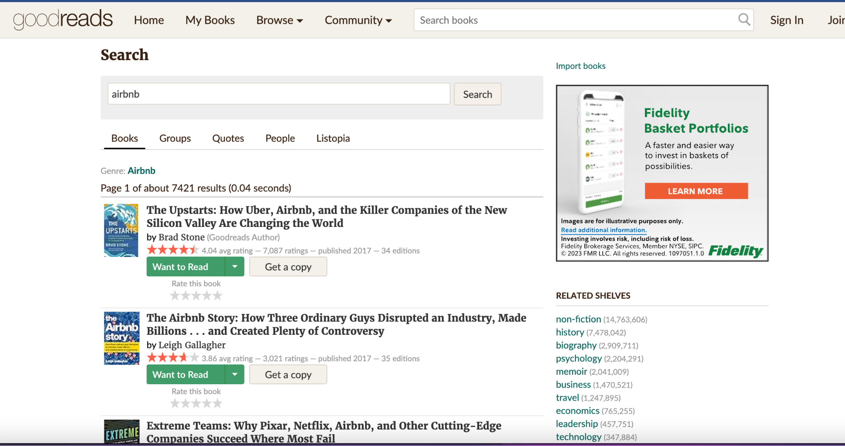

the function returns:

| ['The Upstarts: How Uber, Airbnb, and the Killer Companies of the New Silicon Valley Are Changing the World', 'The Airbnb Story: How Three Ordinary Guys Disrupted an Industry, Made Billions . . . and Created Plenty of Controversy', 'Extreme Teams: Why Pixar, Netflix, Airbnb, and Other Cutting-Edge Companies Succeed Where Most Fail', 'Optimize YOUR Bnb: The Definitive Guide to Ranking #1 in Airbnb Search by a Prior Employee', 'How to Start a Successful Airbnb Business: Quit Your Day Job and Earn Full-time Income on Autopilot With a Profitable Airbnb Business Even if You’re an Absolute Beginner (2023)', "You, Me, and Airbnb: The Savvy Couple's Guide to Turning Midterm Rentals into Big-Time Profits", 'Get Paid For Your Pad: How to Maximize Profit From Your Airbnb Listing', 'How To Invest in Airbnb Properties: Create Wealth and Passive Income Through Smart Vacation Rentals Investing', 'Airbnb Listing Hacks - The Complete Guide To Maximizing Your Bookings And Profits', 'Work From Home: 50 Ways to Make Money Online Analyzed'] |
| --- |

## 

## 

## Grading

| ***Function*** | ***points*** |
| --- | --- |
| **def get_listings_from_search_results(filepath)** | 30 |
| **def get_listing_information(listing_id)** | 30 |
| **def get_detailed_listing_database()** | 20 |
| **def write_csv(data, filename)** | 10 |
| **def check_policy_numbers(data)** | 20 |
| **TestCases (10 points for each)** | 50 |
| **Reflection that shows critical thought** | 40 |
| ***Total*** | **200** |
| **def goodreads_searcher(query):** | 20 pts extra credit |

We will be checking to make sure that you’ve implemented each function correctly. You will need to make sure that you are returning data in the specified format to get full credit. You will also need to make sure that you are calling the other functions when directed to do so.